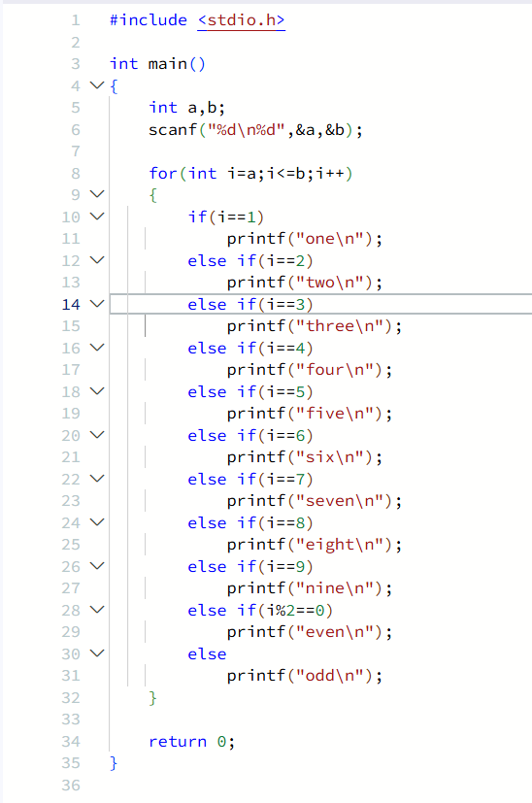
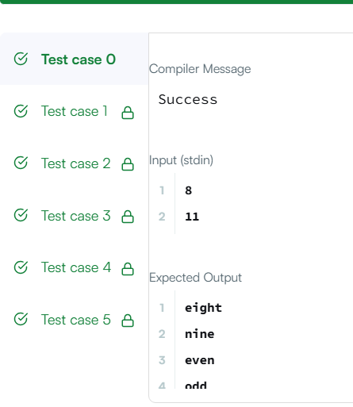

#include <stdio.h>

int main()
{
int a,b;
scanf("%d\n%d",&a,&b);

for(int i=a;i<=b;i++)
{
if(i==1)
printf("one\n");
else if(i==2)
printf("two\n");
else if(i==3)
printf("three\n");
else if(i==4)
printf("four\n");
else if(i==5)
printf("five\n");
else if(i==6)
printf("six\n");
else if(i==7)
printf("seven\n");
else if(i==8)
printf("eight\n");
else if(i==9)
printf("nine\n");
else if(i%2==0)
printf("even\n");
else
printf("odd\n");
}

return 0;
}

